SmartFix
Database Design
Reporting and Repairing Public Infrastructure
Course: ENSF 607 Advanced Software Design and Architecture
Team: Group 6
Version: 2 (October 27, 2026)
Database: PostgreSQL 15+ with PostGIS, hosted on Supabase
Script: smartfix_schema_v2.sql (tested on PostgreSQL 16 + PostGIS 3.4)

Contents
1. Overview
2. Changes from version 1
3. Entity relationship diagram (overview and 6 detail pages)
4. Data dictionary (28 tables)
5. Enumerated types and events
6. Issue status transitions and owners
7. Functions, views and triggers
8. Requirement coverage
9. Using the schema (transaction pattern, running, test results)
10. Open items for the team

1. Overview
SmartFix stores everything in one PostgreSQL database with the PostGIS extension. The schema separates the real-world problem (an issue) from each resident's submission (a report), so several residents can report the same pothole and the city still sends one crew. Every event the modules publish is also written to an events table, which gives operators the full history of an issue and lets each module skip events it has already handled.
Item | Count | Where
Tables | 28 | Section 4 (data dictionary)
Enumerated types | 10 | Section 5
Helper functions | 4 | find_nearby_open_issues, compute_priority_base, work_order_deadline, pick_crew
Views | 5 | v_issue_queue, v_operator_map, v_issue_timeline, v_repair_stats, v_area_hotspots
Triggers | 6 | status ownership and history (2), role checks (4)

Files delivered with this document: smartfix_schema_v2.sql (creates everything, runs in one transaction) and smartfix_lifecycle_test.sql (runs a full issue lifecycle against the schema, checks the result and rolls back).

2. Changes from version 1
Version 1 of the script (Oct 27) was reviewed against the requirements and loaded into a clean database. It worked, with one bug and two gaps. Nothing was renamed or removed, so code written against v1 still works.
Change | Why
Helper functions take INTEGER instead of SMALLINT parameters | In v1, compute_priority_base(3, 2), pick_crew(1, 4) and similar calls failed with "function does not exist". PostgreSQL will not narrow an integer literal, or a Python int sent by the driver, to SMALLINT when choosing a function. Only calls that passed a SMALLINT column worked.
Role checks by trigger (NFR-6) | crew_members.user_id must be a crew user, crews.supervisor_id a supervisor, and review_queue.reviewed_by and work_order_assignments.assigned_by an operator or supervisor. v1 accepted any user in these columns.
COMMENT ON every table and column | The descriptions in this document now live in the database too, so they show up in Supabase's table editor and in \d+.
Two new events: IssueClosed and ReportRejected | Closing an issue (resident confirms, or the 7-day auto-close) and an operator rejecting a report used to change status without publishing anything, so Notifications could not tell the resident (FR-12) and the timeline had no event for them (FR-14). Both are now in the events.event_name check. See Section 5.
End-to-end test script | smartfix_lifecycle_test.sql checks 16 behaviours (Section 9).

3. Entity relationship diagram (overview and 6 detail pages)
Crow's foot notation. The overview on the next page shows the main entities and how they relate. Six detail pages follow, one per subject area, with every attribute; each line runs from a foreign key row to the primary key it references, and dashed tables are shown in full on another page. The same pages are in SmartFix_ER_Diagram.drawio, which opens in draw.io for editing.

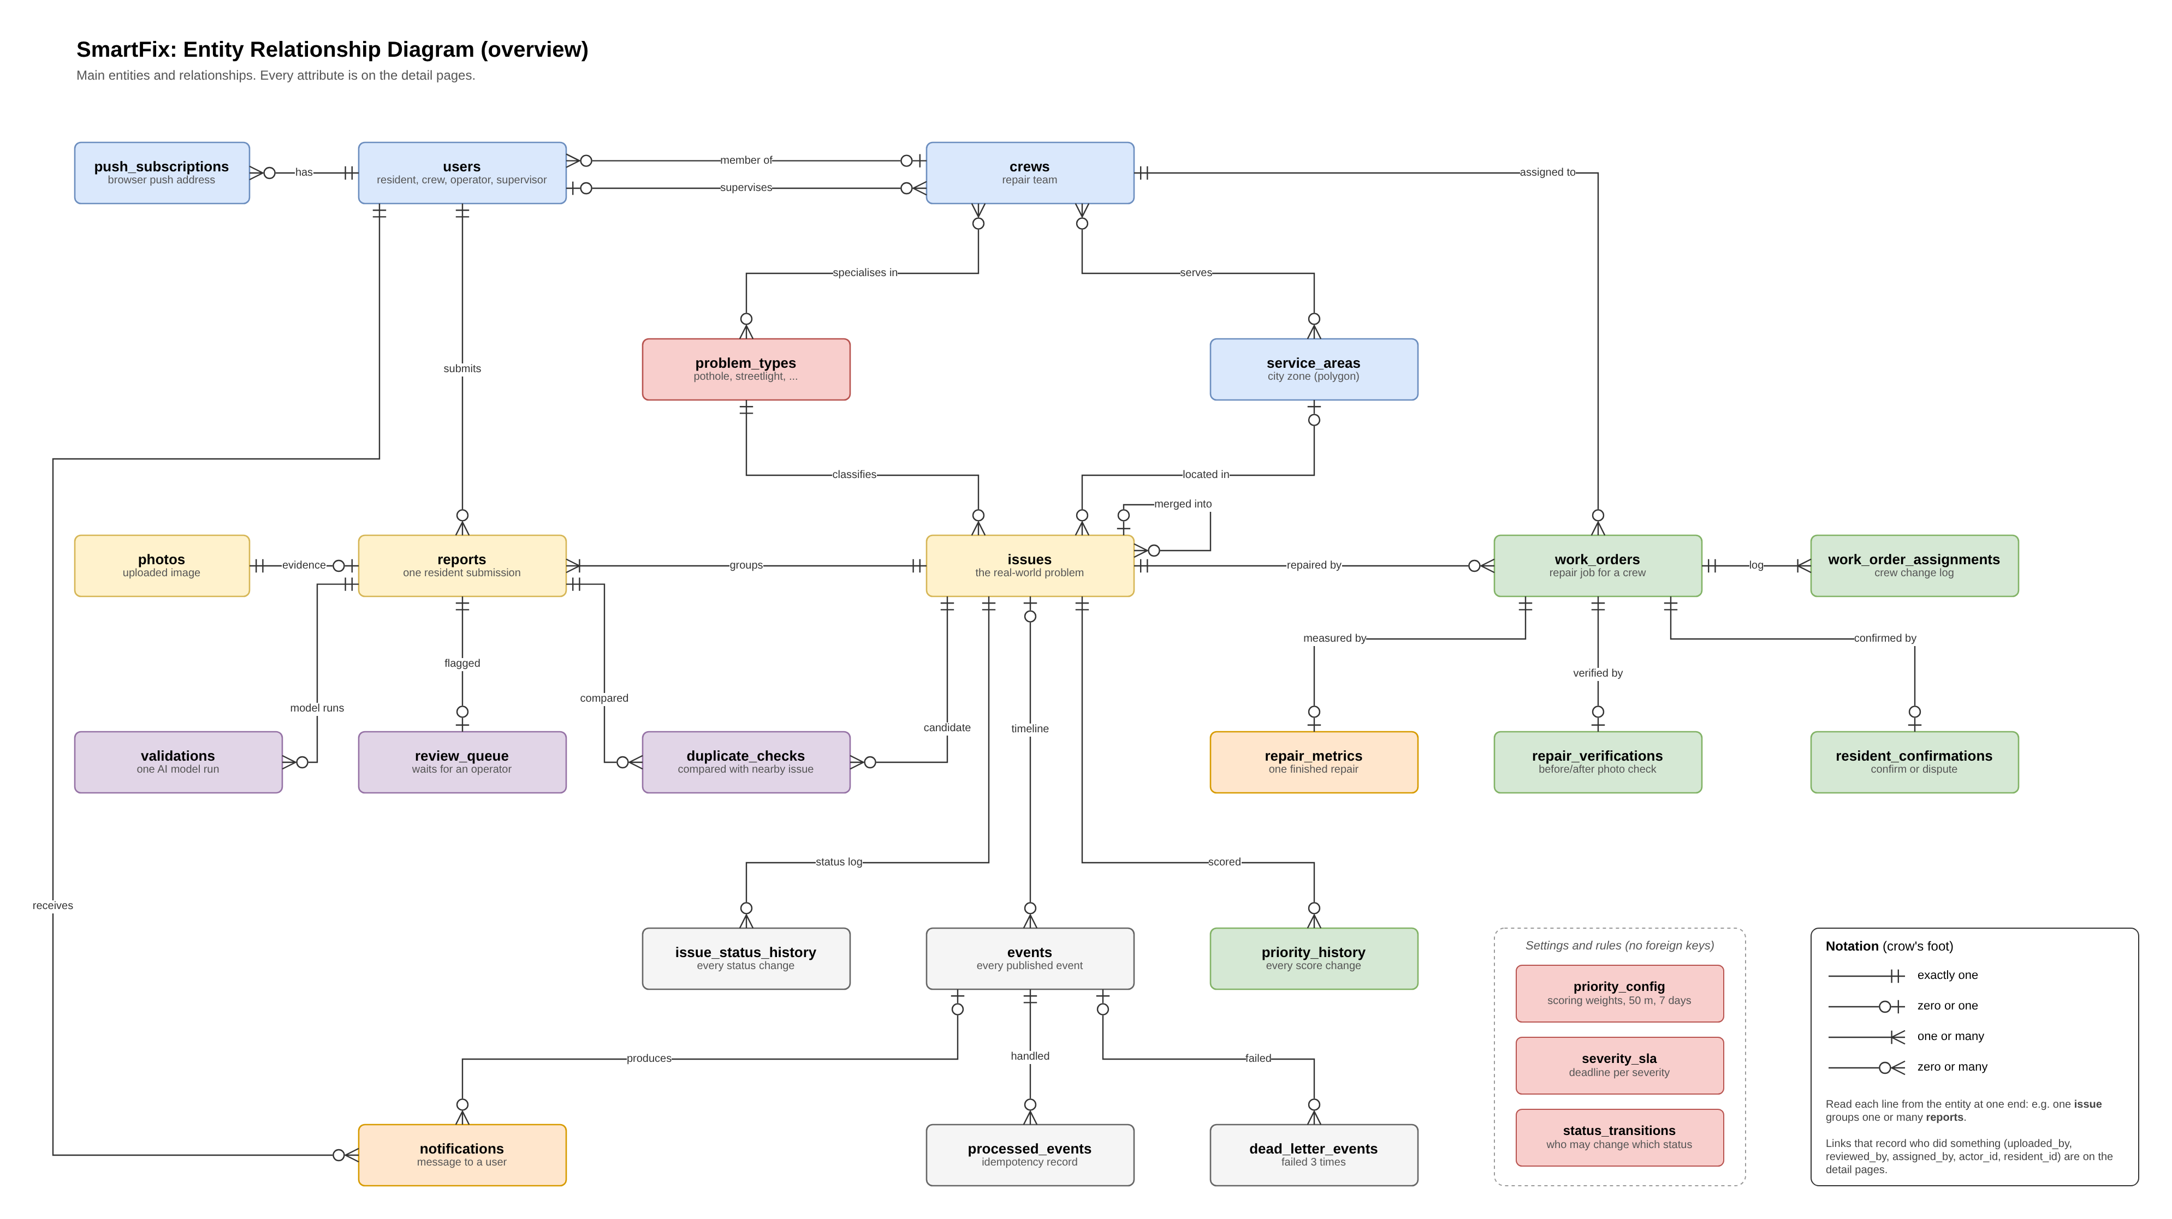
Figure 1. ER diagram, overview

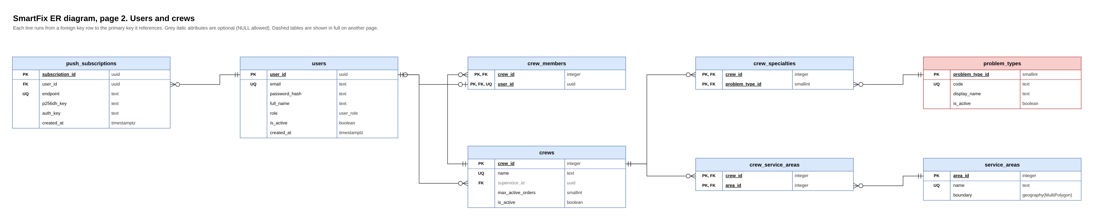
Figure 2. Users and crews

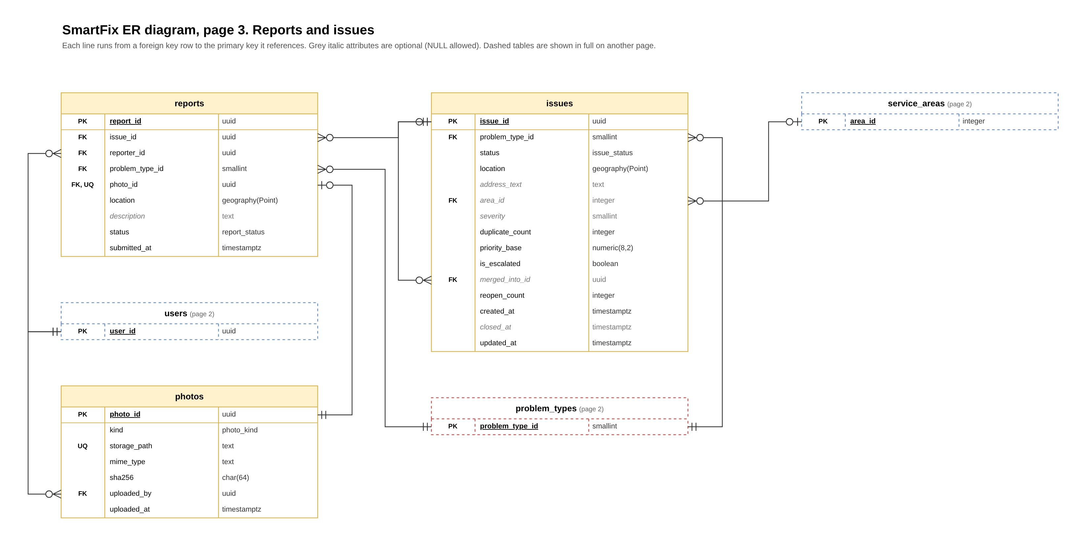
Figure 3. Reports and issues

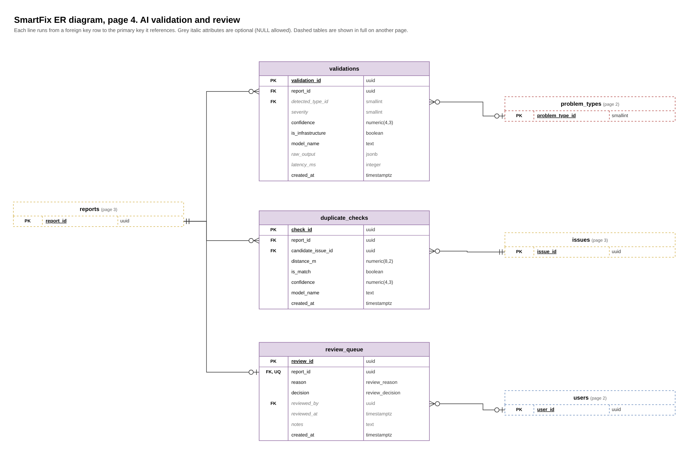
Figure 4. AI validation and review

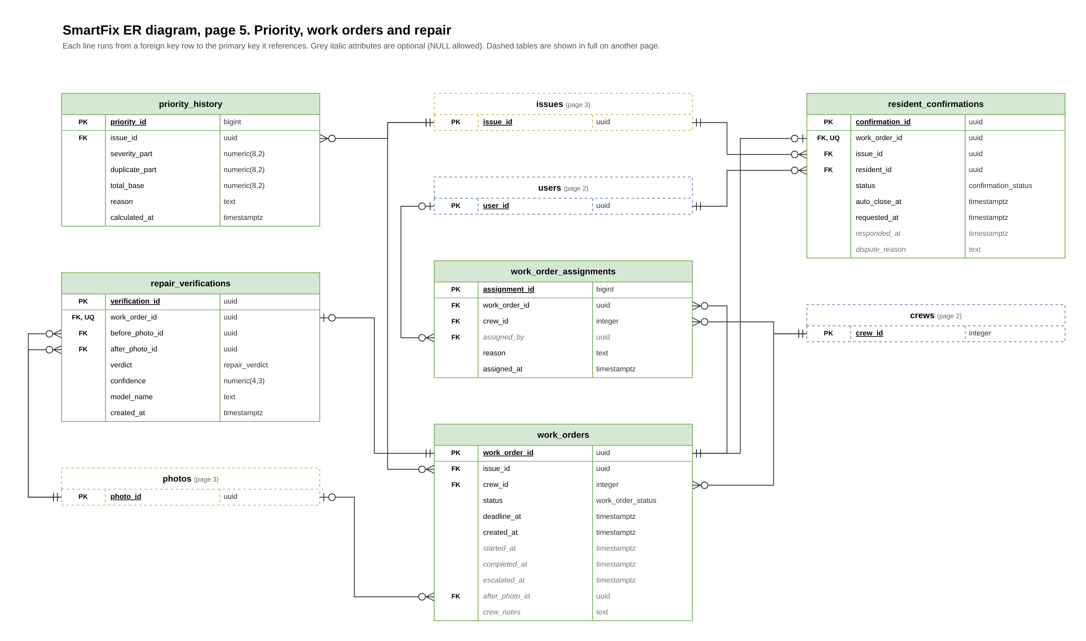
Figure 5. Priority, work orders and repair

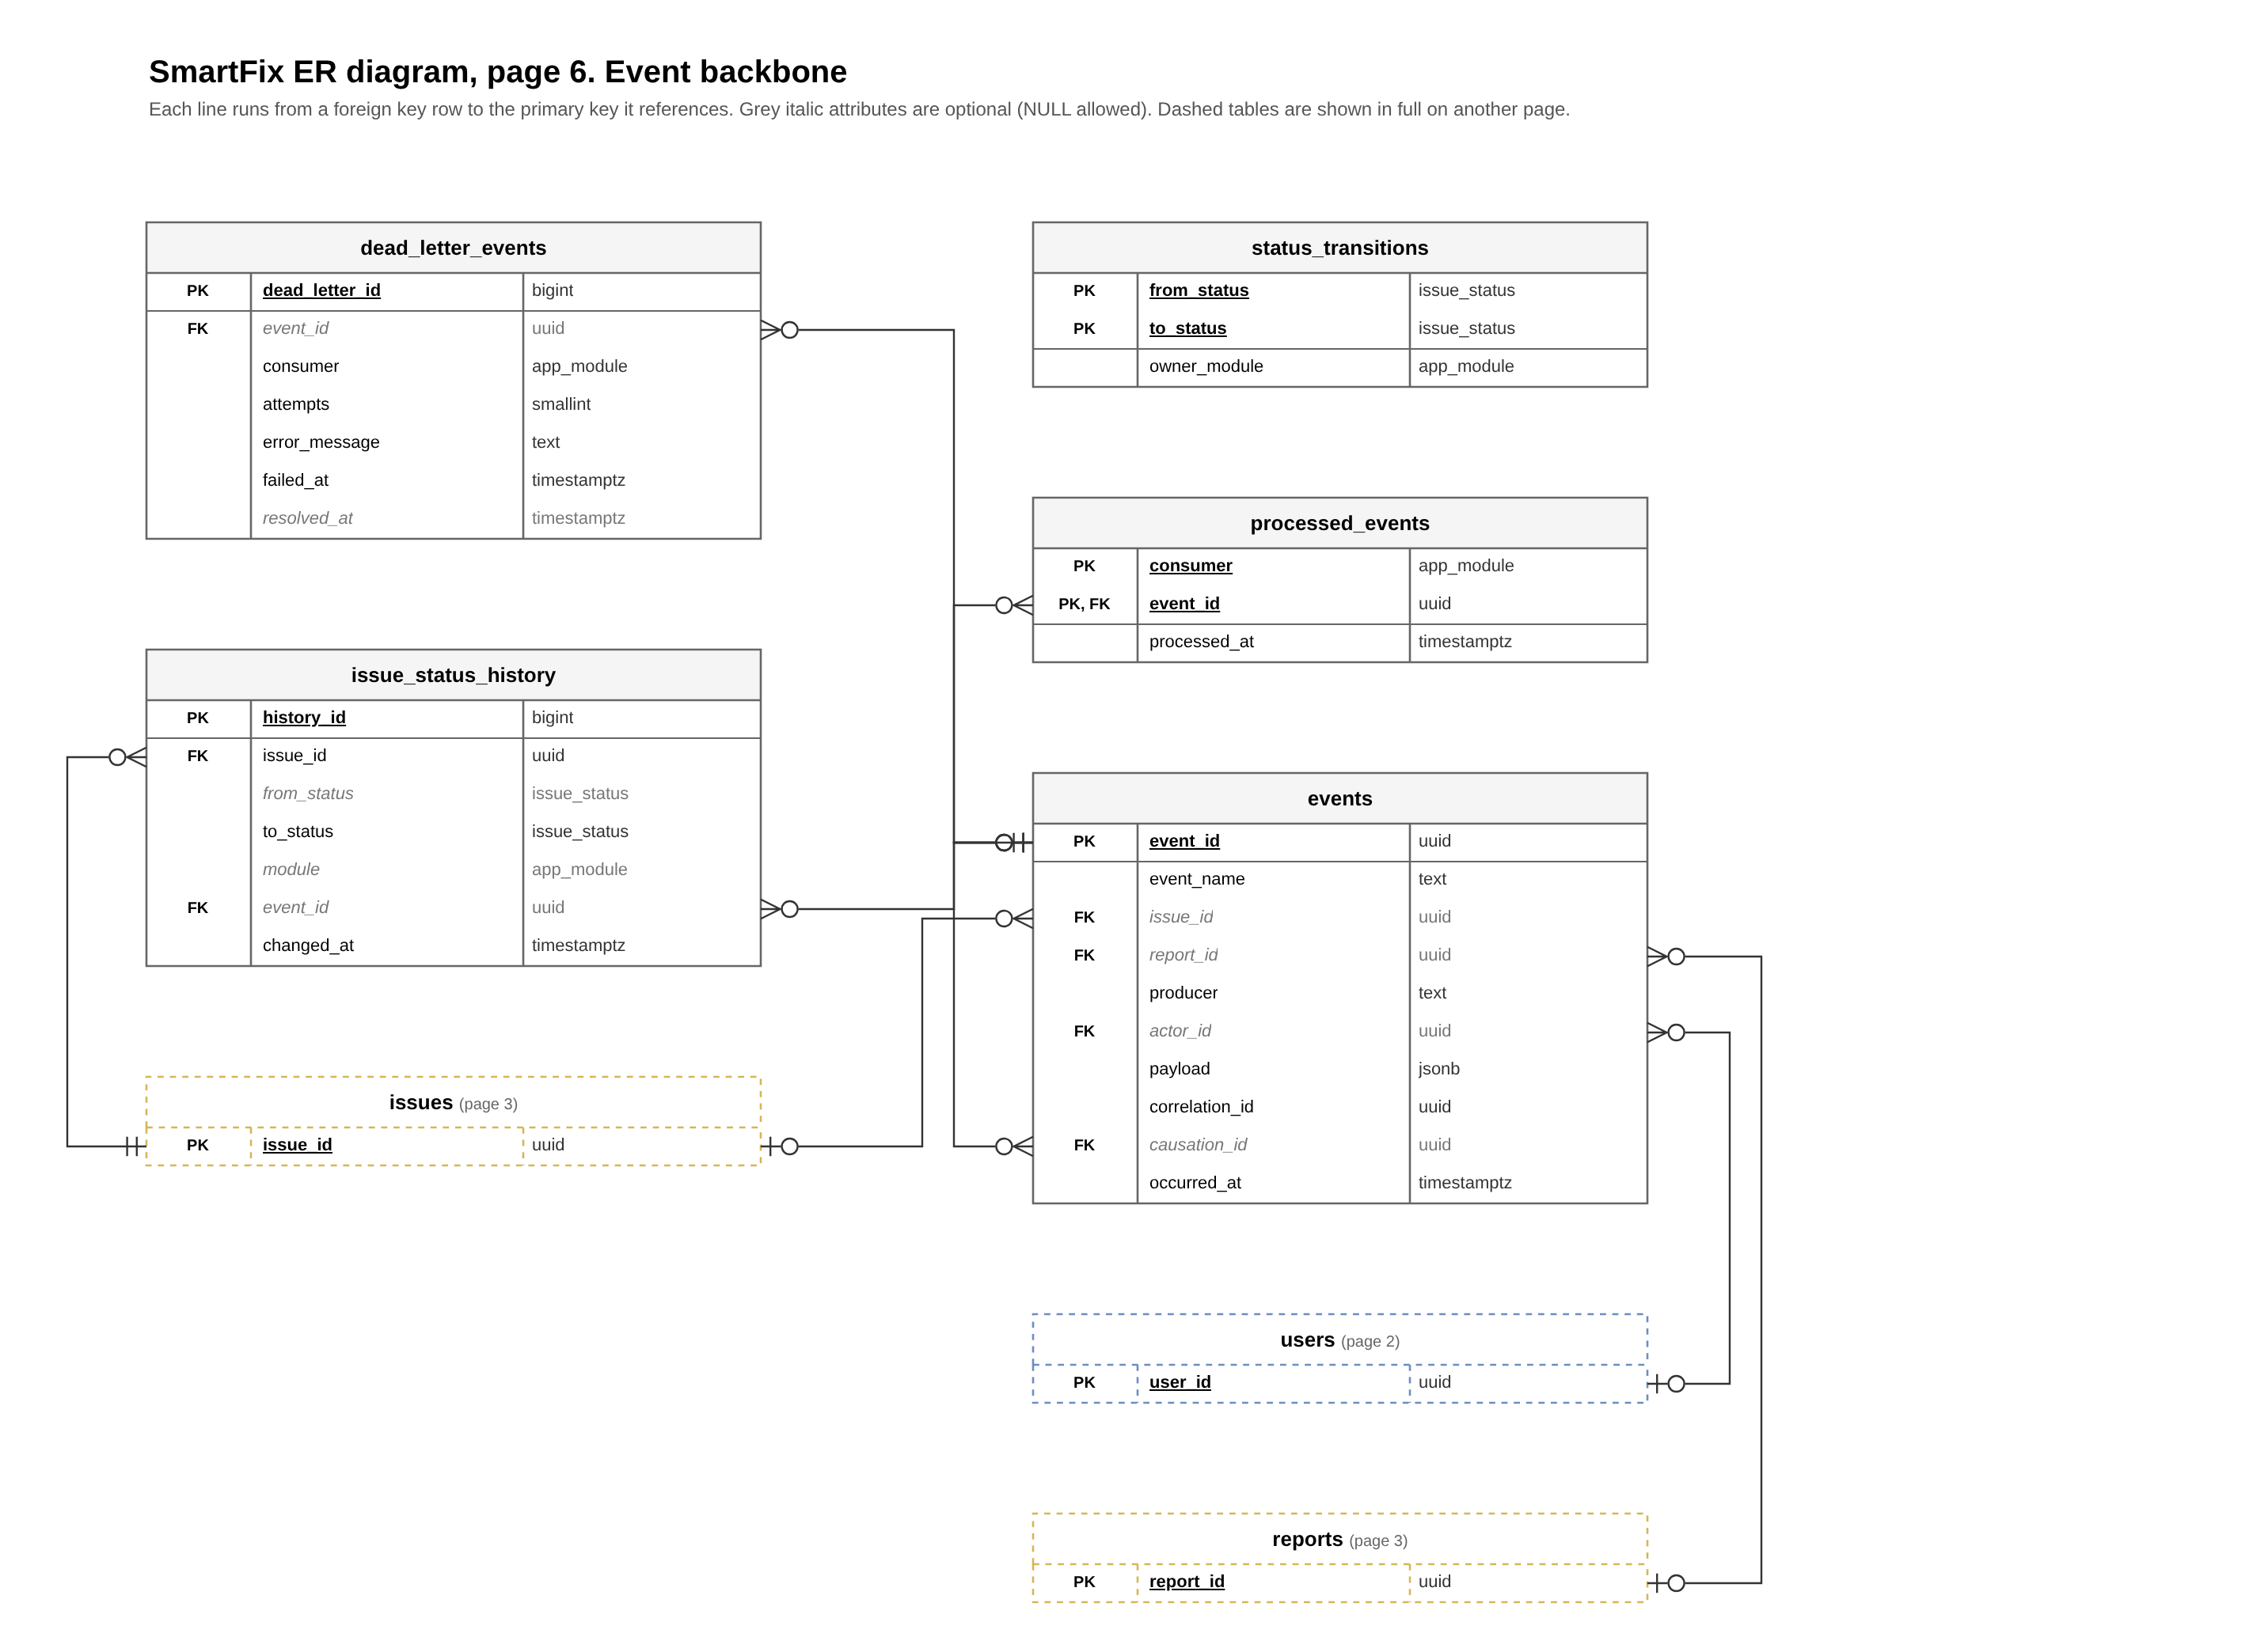
Figure 6. Event backbone

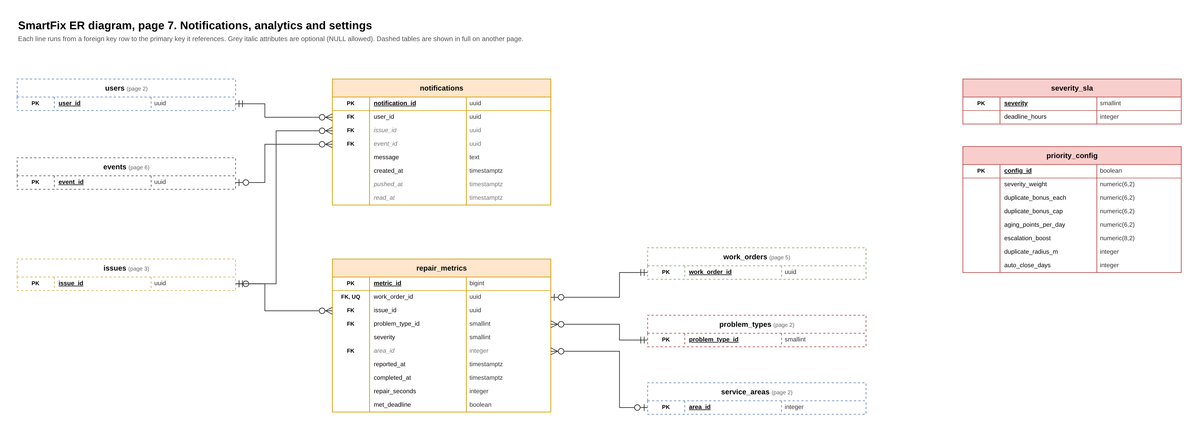
Figure 7. Notifications, analytics and settings

Key design decisions
Decision | Why
Issue and report are separate tables | Many residents can report one pothole (FR-3). Reports keep their own photo, pin and reporter; the issue carries status, severity and priority.
Every submission starts with its own issue in status reported | Keeps the proposal's status flow intact. If Validation finds a duplicate, the report is re-pointed to the existing issue and the new issue becomes merged.
Two extra statuses: rejected and merged | The proposal lists nine statuses, but a report the operator rejects (FR-4) and a merged duplicate (FR-3) need an end state.
Aging is computed when read (v_issue_queue) | Only severity plus the capped duplicate bonus is stored. No background job has to rewrite every row to keep aging current.
Status ownership enforced by a trigger | status_transitions lists which module may make each move. Each module runs SET LOCAL app.module = '...' in its transaction; anything else is rejected (NFR-4). Every change is logged to issue_status_history.
processed_events (consumer, event_id) | INSERT ... ON CONFLICT DO NOTHING. Zero rows inserted means the event was already handled, so the module skips it (NFR-4).
One active work order per issue | Partial unique index. A dispute (FR-9) creates a new work order after the old one is completed.
Tunable values in priority_config and severity_sla | Weights, the duplicate cap, the 50 m radius, the 7-day auto-close and deadlines can change without redeploying.
PostGIS geography columns with GiST indexes | ST_DWithin in metres gives the 50 m duplicate lookup and the map queries directly.

4. Data dictionary
Key: PK primary key, FK foreign key (target shown in the description), UQ unique. Null: "no" means NOT NULL. timestamptz is timestamp with time zone. Defaults are shown where the database fills a value in.

4.1 Users and crews

users
Residents, crew members, operators and supervisors
Attribute | Type | Null | Key | Description
user_id | uuid | no | PK | Unique ID. Default: gen_random_uuid()
email | text | no | UQ | Login name
password_hash | text | no |  | Hashed password
full_name | text | no |  | Display name
role | user_role | no |  | resident, crew, operator or supervisor (drives access)
is_active | boolean | no |  | Account enabled or disabled. Default: true
created_at | timestamptz | no |  | Sign-up time. Default: now()

push_subscriptions
Browser push addresses for notifications
Attribute | Type | Null | Key | Description
subscription_id | uuid | no | PK | Unique ID. Default: gen_random_uuid()
user_id | uuid | no | FK | Owner of the browser (references users(user_id))
endpoint | text | no | UQ | Browser push URL
p256dh_key | text | no |  | Encryption keys required by web push
auth_key | text | no |  | Encryption keys required by web push
created_at | timestamptz | no |  | When subscribed. Default: now()

service_areas
City zones
Attribute | Type | Null | Key | Description
area_id | integer | no | PK | Unique ID. Default: auto-generated identity
name | text | no | UQ | Zone name
boundary | geography(MultiPolygon, 4326) | no |  | Map polygon of the zone

 | Rule
Index | idx_service_areas_boundary: GiST (boundary)

crews
Repair teams
Attribute | Type | Null | Key | Description
crew_id | integer | no | PK | Unique ID. Default: auto-generated identity
name | text | no | UQ | Crew name
supervisor_id | uuid | yes | FK | Supervisor alerted on missed deadlines (references users(user_id))
max_active_orders | smallint | no |  | Workload limit. Default: 5. CHECK (max_active_orders > 0)
is_active | boolean | no |  | Whether the crew can receive work. Default: true

crew_members
Links users to crews
Attribute | Type | Null | Key | Description
crew_id | integer | no | PK, FK | The crew (references crews(crew_id))
user_id | uuid | no | PK, FK, UQ | The member (one crew per person) (references users(user_id))

crew_specialties
Problem types a crew handles
Attribute | Type | Null | Key | Description
crew_id | integer | no | PK, FK | The crew (references crews(crew_id))
problem_type_id | smallint | no | PK, FK | The problem type (references problem_types(problem_type_id))

crew_service_areas
Zones a crew covers
Attribute | Type | Null | Key | Description
crew_id | integer | no | PK, FK | The crew (references crews(crew_id))
area_id | integer | no | PK, FK | The zone (references service_areas(area_id))

4.2 Reports and issues

photos
Every uploaded image
Attribute | Type | Null | Key | Description
photo_id | uuid | no | PK | Unique ID. Default: gen_random_uuid()
kind | photo_kind | no |  | report (before) or after
storage_path | text | no | UQ | File location in storage
mime_type | text | no |  | Image format
sha256 | char(64) | no |  | File fingerprint
uploaded_by | uuid | no | FK | Uploader (references users(user_id))
uploaded_at | timestamptz | no |  | Upload time. Default: now()

issues
The real-world problem, shared by all its reports
Attribute | Type | Null | Key | Description
issue_id | uuid | no | PK | Unique ID. Default: gen_random_uuid()
problem_type_id | smallint | no | FK | Problem type (references problem_types(problem_type_id))
status | issue_status | no |  | Reported, Validated, Prioritized, Assigned, In Progress, Completed, Closed, Reopened, Escalated, plus Rejected and Merged. Default: 'reported'
location | geography(Point, 4326) | no |  | Map point of the problem
address_text | text | yes |  | Readable address
area_id | integer | yes | FK | Service area it falls in (references service_areas(area_id))
severity | smallint | yes |  | 1 to 5 from the vision model. CHECK ((severity >= 1) AND (severity <= 5))
duplicate_count | integer | no |  | Number of extra reports merged in. Default: 0. CHECK (duplicate_count >= 0)
priority_base | numeric(8,2) | no |  | Severity plus capped duplicate bonus (aging is added when read). Default: 0
is_escalated | boolean | no |  | True after a missed deadline. Default: false
merged_into_id | uuid | yes | FK | Issue this one was merged into, if a duplicate (references issues(issue_id))
reopen_count | integer | no |  | Times a resident disputed the repair. Default: 0
created_at | timestamptz | no |  | Report time, which starts the aging clock. Default: now()
closed_at | timestamptz | yes |  | Closing time
updated_at | timestamptz | no |  | Last change. Default: now()

 | Rule
Constraint | CHECK ((status = 'merged') = (merged_into_id IS NOT NULL))
Constraint | CHECK (merged_into_id IS DISTINCT FROM issue_id)
Index | idx_issues_location: GiST (location)
Index | idx_issues_open_by_type: (problem_type_id) WHERE (status <> ALL (ARRAY['closed', 'rejected', 'merged']))
Index | idx_issues_status: (status)

reports
One resident submission
Attribute | Type | Null | Key | Description
report_id | uuid | no | PK | Unique ID. Default: gen_random_uuid()
issue_id | uuid | no | FK | Issue the report belongs to (references issues(issue_id))
reporter_id | uuid | no | FK | Resident who submitted it (references users(user_id))
problem_type_id | smallint | no | FK | Category the resident chose (references problem_types(problem_type_id))
photo_id | uuid | no | FK, UQ | The photo submitted (references photos(photo_id))
location | geography(Point, 4326) | no |  | Pin the resident dropped
description | text | yes |  | Optional text
status | report_status | no |  | submitted, validated, duplicate, needs_review or rejected. Default: 'submitted'
submitted_at | timestamptz | no |  | Submission time. Default: now()

 | Rule
Index | idx_reports_issue: (issue_id)
Index | idx_reports_reporter: (reporter_id, submitted_at DESC)
Index | idx_reports_location: GiST (location)

4.3 AI validation and operator review

validations
One model run on a report (FR-2)
Attribute | Type | Null | Key | Description
validation_id | uuid | no | PK | Unique ID. Default: gen_random_uuid()
report_id | uuid | no | FK | Report analysed (references reports(report_id))
detected_type_id | smallint | yes | FK | Problem type the model found (references problem_types(problem_type_id))
severity | smallint | yes |  | Score 1 to 5. CHECK ((severity >= 1) AND (severity <= 5))
confidence | numeric(4,3) | no |  | Model certainty, 0 to 1
is_infrastructure | boolean | no |  | False if the photo isn't infrastructure
model_name | text | no |  | Model used (Qwen3-VL or the Gemma fallback)
raw_output | jsonb | yes |  | Full model response, kept for accuracy testing
latency_ms | integer | yes |  | Processing time (checks the 15 s target). CHECK (latency_ms >= 0)
created_at | timestamptz | no |  | Time of run. Default: now()

 | Rule
Constraint | CHECK ((confidence >= (0)) AND (confidence <= (1)))
Index | idx_validations_report: (report_id)

duplicate_checks
Comparison of a report against a nearby open issue (FR-3)
Attribute | Type | Null | Key | Description
check_id | uuid | no | PK | Unique ID. Default: gen_random_uuid()
report_id | uuid | no | FK | New report (references reports(report_id))
candidate_issue_id | uuid | no | FK | Existing issue compared against (references issues(issue_id))
distance_m | numeric(8,2) | no |  | Distance between them. CHECK (distance_m >= (0))
is_match | boolean | no |  | Whether the model says they match
confidence | numeric(4,3) | no |  | Model certainty
model_name | text | no |  | Model used
created_at | timestamptz | no |  | Time of check. Default: now()

 | Rule
Constraint | CHECK ((confidence >= (0)) AND (confidence <= (1)))
Constraint | UNIQUE (report_id, candidate_issue_id)

review_queue
Reports waiting for an operator (FR-4)
Attribute | Type | Null | Key | Description
review_id | uuid | no | PK | Unique ID. Default: gen_random_uuid()
report_id | uuid | no | FK, UQ | Report under review (references reports(report_id))
reason | review_reason | no |  | low_confidence or not_infrastructure
decision | review_decision | no |  | pending, approved or rejected. Default: 'pending'
reviewed_by | uuid | yes | FK | Operator who decided (references users(user_id))
reviewed_at | timestamptz | yes |  | Decision time
notes | text | yes |  | Operator comment
created_at | timestamptz | no |  | When queued. Default: now()

 | Rule
Constraint | CHECK ((decision = 'pending') = ((reviewed_by IS NULL) AND (reviewed_at IS NULL)))
Index | idx_review_pending: (created_at) WHERE (decision = 'pending')

4.4 Priority, work orders and repair

priority_history
Audit trail of score changes (FR-5)
Attribute | Type | Null | Key | Description
priority_id | bigint | no | PK | Unique ID. Default: auto-generated identity
issue_id | uuid | no | FK | Issue scored (references issues(issue_id))
severity_part | numeric(8,2) | no |  | Points from severity
duplicate_part | numeric(8,2) | no |  | Points from duplicates (after the cap)
total_base | numeric(8,2) | no |  | Sum stored on the issue
reason | text | no |  | Why it was recalculated, e.g. validated or disputed
calculated_at | timestamptz | no |  | Time. Default: now()

 | Rule
Index | idx_priority_history_issue: (issue_id, calculated_at DESC)

work_orders
Repair jobs given to crews (FR-6, FR-7)
Attribute | Type | Null | Key | Description
work_order_id | uuid | no | PK | Unique ID. Default: gen_random_uuid()
issue_id | uuid | no | FK | Issue to fix (references issues(issue_id))
crew_id | integer | no | FK | Assigned crew (references crews(crew_id))
status | work_order_status | no |  | assigned, in_progress, completed or cancelled. Default: 'assigned'
deadline_at | timestamptz | no |  | Due time, set from severity
created_at | timestamptz | no |  | Creation time. Default: now()
started_at | timestamptz | yes |  | Work began
completed_at | timestamptz | yes |  | Work finished
escalated_at | timestamptz | yes |  | When the deadline was missed
after_photo_id | uuid | yes | FK | Photo uploaded by the crew (references photos(photo_id))
crew_notes | text | yes |  | Crew comments

 | Rule
Constraint | CHECK ((completed_at IS NULL) OR (started_at IS NULL) OR (completed_at >= started_at))
Constraint | CHECK ((status <> 'completed') OR ((completed_at IS NOT NULL) AND (after_photo_id IS NOT NULL)))
Index | uq_work_orders_one_active (unique): (issue_id) WHERE (status = ANY (ARRAY['assigned', 'in_progress']))
Index | idx_work_orders_crew: (crew_id, status)
Index | idx_work_orders_deadline: (deadline_at) WHERE ((status = ANY (ARRAY['assigned', 'in_progress'])) AND (escalated_at IS NULL))

work_order_assignments
Log of crew changes (FR-13)
Attribute | Type | Null | Key | Description
assignment_id | bigint | no | PK | Unique ID. Default: auto-generated identity
work_order_id | uuid | no | FK | The work order (references work_orders(work_order_id))
crew_id | integer | no | FK | Crew it was given to (references crews(crew_id))
assigned_by | uuid | yes | FK | Operator, or empty if automatic (references users(user_id))
reason | text | no |  | auto_match, manual reassign, etc.. Default: 'auto_match'
assigned_at | timestamptz | no |  | Time. Default: now()

repair_verifications
Before/after photo check (FR-8)
Attribute | Type | Null | Key | Description
verification_id | uuid | no | PK | Unique ID. Default: gen_random_uuid()
work_order_id | uuid | no | FK, UQ | The work order (references work_orders(work_order_id))
before_photo_id | uuid | no | FK | Original photo (references photos(photo_id))
after_photo_id | uuid | no | FK | Crew's photo (references photos(photo_id))
verdict | repair_verdict | no |  | repaired, not_repaired or unclear
confidence | numeric(4,3) | no |  | Model certainty
model_name | text | no |  | Model used
created_at | timestamptz | no |  | Time. Default: now()

 | Rule
Constraint | CHECK ((confidence >= (0)) AND (confidence <= (1)))

resident_confirmations
Resident confirms or disputes (FR-9, FR-10)
Attribute | Type | Null | Key | Description
confirmation_id | uuid | no | PK | Unique ID. Default: gen_random_uuid()
work_order_id | uuid | no | FK, UQ | The completed work order (references work_orders(work_order_id))
issue_id | uuid | no | FK | The issue (references issues(issue_id))
resident_id | uuid | no | FK | Original reporter (references users(user_id))
status | confirmation_status | no |  | pending, confirmed, disputed or auto_closed. Default: 'pending'
auto_close_at | timestamptz | no |  | 7-day deadline for a reply
requested_at | timestamptz | no |  | When the resident was asked. Default: now()
responded_at | timestamptz | yes |  | When they answered
dispute_reason | text | yes |  | Why they disagree (required if disputed)

 | Rule
Constraint | CHECK ((status = ANY (ARRAY['pending', 'auto_closed'])) = (responded_at IS NULL))
Constraint | CHECK ((status <> 'disputed') OR (dispute_reason IS NOT NULL))
Index | idx_confirmations_due: (auto_close_at) WHERE (status = 'pending')

4.5 Event backbone

events
Every event ever published (FR-14)
Attribute | Type | Null | Key | Description
event_id | uuid | no | PK | ID set by the producer
event_name | text | no |  | One of the twelve events, e.g. IssueReported or IssueClosed
issue_id | uuid | yes | FK | Related issue (references issues(issue_id))
report_id | uuid | yes | FK | Related report (references reports(report_id))
producer | text | no |  | Module, crew portal or scheduler
actor_id | uuid | yes | FK | Person who triggered it, if any (references users(user_id))
payload | jsonb | no |  | Event data in JSON
correlation_id | uuid | no |  | Groups all events from one report's journey
causation_id | uuid | yes | FK | Event that caused this one (references events(event_id))
occurred_at | timestamptz | no |  | Time. Default: now()

 | Rule
Constraint | CHECK (event_name = ANY (ARRAY['IssueReported', 'IssueValidated', 'IssueDuplicateDetected', 'IssueNeedsReview', 'IssuePrioritized', 'WorkOrderCreated', 'WorkOrderStatusChanged', 'RepairCompleted', 'RepairDisputed', 'DeadlineMissed', 'IssueClosed', 'ReportRejected']))
Index | idx_events_issue_time: (issue_id, occurred_at)
Index | idx_events_name_time: (event_name, occurred_at DESC)
Index | idx_events_correlation: (correlation_id)

processed_events
Which module already handled which event (NFR-4)
Attribute | Type | Null | Key | Description
consumer | app_module | no | PK | Module name
event_id | uuid | no | PK, FK | Event handled (references events(event_id))
processed_at | timestamptz | no |  | Time. Default: now()

dead_letter_events
Events that failed 3 times (NFR-3)
Attribute | Type | Null | Key | Description
dead_letter_id | bigint | no | PK | Unique ID. Default: auto-generated identity
event_id | uuid | yes | FK | Failed event (references events(event_id))
consumer | app_module | no |  | Module that failed
attempts | smallint | no |  | Number of tries. Default: 3
error_message | text | no |  | What went wrong
failed_at | timestamptz | no |  | Time. Default: now()
resolved_at | timestamptz | yes |  | When fixed or replayed

status_transitions
The allowed status changes and who owns them
Attribute | Type | Null | Key | Description
from_status | issue_status | no | PK | Current status
to_status | issue_status | no | PK | Next status
owner_module | app_module | no |  | The only module allowed to make this change

issue_status_history
Log of every status change
Attribute | Type | Null | Key | Description
history_id | bigint | no | PK | Unique ID. Default: auto-generated identity
issue_id | uuid | no | FK | The issue (references issues(issue_id))
from_status | issue_status | yes |  | Previous status (empty for the first)
to_status | issue_status | no |  | New status
module | app_module | yes |  | Module that made the change
event_id | uuid | yes | FK | Event that triggered it (references events(event_id))
changed_at | timestamptz | no |  | Time. Default: now()

 | Rule
Index | idx_status_history_issue: (issue_id, changed_at)

4.6 Notifications and analytics

notifications
Plain-language messages to residents (FR-12)
Attribute | Type | Null | Key | Description
notification_id | uuid | no | PK | Unique ID. Default: gen_random_uuid()
user_id | uuid | no | FK | Recipient (references users(user_id))
issue_id | uuid | yes | FK | Related issue (references issues(issue_id))
event_id | uuid | yes | FK | Event that produced the message (unique per user, which prevents double sends) (references events(event_id))
message | text | no |  | Text written by the local model
created_at | timestamptz | no |  | Time created. Default: now()
pushed_at | timestamptz | yes |  | Time sent to the browser
read_at | timestamptz | yes |  | Time the user read it

 | Rule
Constraint | UNIQUE (user_id, event_id)
Index | idx_notifications_user_unread: (user_id, created_at DESC) WHERE (read_at IS NULL)

repair_metrics
One row per finished repair (FR-15)
Attribute | Type | Null | Key | Description
metric_id | bigint | no | PK | Unique ID. Default: auto-generated identity
work_order_id | uuid | no | FK, UQ | The work order (references work_orders(work_order_id))
issue_id | uuid | no | FK | The issue (references issues(issue_id))
problem_type_id | smallint | no | FK | Problem type (references problem_types(problem_type_id))
severity | smallint | no |  | Severity at repair time. CHECK ((severity >= 1) AND (severity <= 5))
area_id | integer | yes | FK | Service area (references service_areas(area_id))
reported_at | timestamptz | no |  | When the issue was first reported
completed_at | timestamptz | no |  | When the repair finished
repair_seconds | integer | no |  | Total repair time. CHECK (repair_seconds >= 0)
met_deadline | boolean | no |  | Whether the deadline was met

 | Rule
Index | idx_repair_metrics_type: (problem_type_id)

4.7 Reference data and settings

problem_types
The categories of infrastructure problem
Attribute | Type | Null | Key | Description
problem_type_id | smallint | no | PK | Unique ID. Default: auto-generated identity
code | text | no | UQ | Short machine name, e.g. pothole
display_name | text | no |  | Label shown to users
is_active | boolean | no |  | Whether residents can still pick it. Default: true

severity_sla
The repair deadline for each severity level
Attribute | Type | Null | Key | Description
severity | smallint | no | PK | Severity 1 to 5. CHECK ((severity >= 1) AND (severity <= 5))
deadline_hours | integer | no |  | Hours a crew has to finish (FR-6). CHECK (deadline_hours > 0)

priority_config
One row of tunable scoring rules
Attribute | Type | Null | Key | Description
config_id | boolean | no | PK | Always true, so only one row can exist. Default: true
severity_weight | numeric(6,2) | no |  | Points per severity level. Default: 10
duplicate_bonus_each | numeric(6,2) | no |  | Points added per duplicate report. Default: 2
duplicate_bonus_cap | numeric(6,2) | no |  | Maximum duplicate bonus, so repeat reporting can't dominate. Default: 10
aging_points_per_day | numeric(6,2) | no |  | Points gained per day an issue stays open. Default: 1.5
escalation_boost | numeric(8,2) | no |  | Large bonus that puts escalated issues first. Default: 1000
duplicate_radius_m | integer | no |  | Distance for duplicate matching (50 m). Default: 50
auto_close_days | integer | no |  | Days before silent auto-close (7). Default: 7

 | Rule
Constraint | CHECK (config_id)

5. Enumerated types and events

Enumerated types
Type | Values
app_module | reports, validation, priority, work_orders, notifications, analytics
confirmation_status | pending, confirmed, disputed, auto_closed
issue_status | reported, validated, prioritized, assigned, in_progress, completed, closed, reopened, escalated, rejected, merged
photo_kind | report, after
repair_verdict | repaired, not_repaired, unclear
report_status | submitted, validated, duplicate, needs_review, rejected
review_decision | pending, approved, rejected
review_reason | low_confidence, not_infrastructure
user_role | resident, crew, operator, supervisor
work_order_status | assigned, in_progress, completed, cancelled

Events (events.event_name)
events.event_name accepts exactly these twelve names. The last two were added in v2.
Event | Published by | Consumed by | Result
IssueReported | Reports | Validation | AI classifies the photo and rates severity.
IssueValidated | Validation | Priority, Notifications | Priority calculated; resident told.
IssueDuplicateDetected | Validation | Priority, Notifications | Report merged into the existing issue.
IssueNeedsReview | Validation | Operator dashboard | Operator approves or rejects.
IssuePrioritized | Priority | Work Orders, dashboard | Work order created or moved in the queue.
WorkOrderCreated | Work Orders | Notifications, dashboard, scheduler | Crew notified; deadline set.
WorkOrderStatusChanged | Work Orders (crew portal) | Notifications, dashboard | Resident and operator see progress.
RepairCompleted | Work Orders (crew portal) | Validation, Notifications, Analytics | Photos compared; resident asked to confirm; repair time recorded.
RepairDisputed | Reports | Priority, Work Orders | Issue reopened with higher priority.
DeadlineMissed | Scheduler | Priority, Notifications | Issue escalated; supervisor alerted.
IssueClosed (new) | Reports | Notifications, dashboard | Resident told the issue is closed (confirmed or auto-closed after 7 days); pin leaves the map. Payload: work_order_id, closed_by.
ReportRejected (new) | Validation (operator review) | Notifications, dashboard | Resident told why the report was rejected; item leaves the review list. Payload: review_id, reason, notes.

6. Issue status transitions and owners
These rows are seeded into status_transitions. The trigger trg_issue_status_transition rejects any other change, and any change made by a module that does not own it (NFR-4). The state machine diagram shows the same rules.
From | To | Owner module
completed | reopened | reports
completed | closed | reports
reported | rejected | validation
reported | validated | validation
reported | merged | validation
validated | prioritized | priority
prioritized | escalated | priority
assigned | escalated | priority
in_progress | escalated | priority
reopened | prioritized | priority
prioritized | assigned | work_orders
assigned | in_progress | work_orders
in_progress | completed | work_orders
escalated | assigned | work_orders
escalated | in_progress | work_orders
escalated | completed | work_orders

Repair deadlines by severity (severity_sla, starting values): severity 5: 8 h, severity 4: 24 h, severity 3: 72 h, severity 2: 168 h, severity 1: 336 h.

7. Functions, views and triggers
Name | Kind | What it does | Req.
find_nearby_open_issues(location, problem_type_id, exclude_issue) | function | Open issues of the same type within duplicate_radius_m (50 m), nearest first. Used by Validation before the model compares photos. | FR-3
compute_priority_base(severity, duplicates) | function | severity x severity_weight + min(duplicates x duplicate_bonus_each, duplicate_bonus_cap). | FR-5
work_order_deadline(severity, from) | function | from + severity_sla.deadline_hours. | FR-6
pick_crew(problem_type_id, area_id) | function | Active crew with the right specialty, covering the area and below max_active_orders, least loaded first. | FR-6
v_issue_queue | view | Live priority queue: priority_base + aging_points_per_day x days open + escalation_boost if escalated. | FR-5, FR-11
v_operator_map | view | Queue rows with lat/lng split out for React-Leaflet, plus the active work order. | FR-13
v_issue_timeline | view | Events and status changes for one issue, in time order. | FR-14
v_repair_stats | view | Repairs, average repair hours and % on time by problem type. | FR-15
v_area_hotspots | view | Issues and repeat reports per service area over 30 days (SDG 9.1 equity stretch goal). | stretch
trg_issue_status_transition | trigger | Checks status ownership, stamps updated_at/closed_at, logs to issue_status_history. | NFR-4, FR-14
trg_issue_initial_status | trigger | Logs the first reported status of every new issue. | FR-14
trg_crew_members_role, trg_crews_supervisor_role, trg_review_queue_reviewer_role, trg_assignments_assigner_role | trigger | Role checks added in v2 (enforce_user_role). | NFR-6

8. Requirement coverage
Requirement | Where in the database
FR-1 submit report | reports, photos, problem_types
FR-2 classify and rate severity | validations
FR-3 duplicates within 50 m | find_nearby_open_issues(), duplicate_checks, issues.merged_into_id
FR-4 operator review | review_queue
FR-5 priority score | priority_config, compute_priority_base(), v_issue_queue, priority_history
FR-6 crew match and deadline | pick_crew(), work_order_deadline(), severity_sla
FR-7 crew updates and after photo | work_orders, photos (kind = after)
FR-8 before/after check | repair_verifications
FR-9, FR-10 dispute and 7-day close | resident_confirmations (auto_close_at)
FR-11 escalation | work_orders.escalated_at, issues.is_escalated, idx_work_orders_deadline
FR-12 push notifications | notifications, push_subscriptions
FR-13 live map and reassign | v_operator_map, work_order_assignments
FR-14 event history | events, issue_status_history, v_issue_timeline
FR-15 repair statistics | repair_metrics, v_repair_stats
NFR-1 15 s classification | validations.latency_ms
NFR-3 dead-letter queue | dead_letter_events
NFR-4 idempotency and ownership | processed_events, status_transitions + trigger
NFR-6 role-based access | users.role, role-check triggers, crew_members (row access enforced in FastAPI; Supabase RLS optional)

9. Using the schema

Transaction pattern for every consumer
BEGIN;
SET LOCAL app.module = 'priority';
SET LOCAL app.event_id = '<event uuid>';
INSERT INTO processed_events (consumer, event_id)
VALUES ('priority', '<event uuid>') ON CONFLICT DO NOTHING;
-- 0 rows inserted => already handled: ROLLBACK and ack the message
-- ... do the work, e.g. UPDATE issues SET status = 'prioritized' ...
-- ... INSERT INTO events (...) for any event this module will publish
COMMIT;
-- only now publish the new event to RabbitMQ, then ack the incoming one

Producers follow the same order: write the event row and the state change in one transaction, commit, then publish. processed_events and notifications reference events(event_id), so a consumer that receives an event before its row is committed would fail the foreign key.

Running the scripts
psql "$DATABASE_URL" -v ON_ERROR_STOP=1 -f smartfix_schema_v2.sql
psql "$DATABASE_URL" -v ON_ERROR_STOP=1 -f smartfix_lifecycle_test.sql

On Supabase, run the schema in the SQL editor of an empty project (PostGIS is available as an extension). The script uses its own users table; to use Supabase Auth instead, point user_id references at auth.users(id) and keep users as a profile table.

Test results
smartfix_lifecycle_test.sql was run on PostgreSQL 16 with PostGIS 3.4. All 16 checks passed:
- Setup: users, service area, crew, specialty and coverage
- Role checks reject a resident as crew member and an operator as crew supervisor
- FR-1 report submitted, initial status logged
- NFR-4 a second delivery of the same event is detected and skipped
- FR-2 validated; an out-of-turn transition by the wrong module is rejected
- FR-5 priority of a severity-4 issue is 40
- FR-3 a report 30 m away is found, merged, priority rises to 42, and the duplicate bonus caps at 10
- FR-6 the right crew is picked, the deadline is 24 h, a second active work order is refused
- FR-11 an overdue order is found by the scheduler query and the issue jumps to priority 1042
- FR-7, FR-8 repair completed with an after photo and verified
- FR-9 a dispute reopens the issue and a second work order runs to completion
- FR-10 an unanswered confirmation auto-closes after 7 days, closed_at is stamped and IssueClosed is recorded
- FR-15 repair statistics show 30 h average repair time
- FR-14 the timeline holds all 13 status changes plus 2 events
- FR-4 an operator rejects a flagged report and ReportRejected appears on its timeline; a resident cannot review; an unknown event name is refused
- FR-12 a second notification for the same user and event is refused

10. Open items for the team
Found while building the diagrams and testing the schema. The first two are decided; the rest still need the team.
- Decided: IssueClosed and ReportRejected added. Done in this version (Section 5). The proposal and architecture document still list ten events and need the two new rows.
- Decided: the scheduler runs every few minutes. Matches the proposal and the diagrams. The architecture document still says every day and needs updating; a daily check could miss the 8-hour severity 5 deadline by most of a day.
- Who owns the 7-day auto-close. The completed to closed move belongs to the Reports module, so the diagrams show Reports running the periodic check. Notifications creates the pending confirmation when it handles RepairCompleted, because Reports does not consume that event.
- Starting values to confirm. SLA hours (8, 24, 72, 168, 336), priority weights (10 per severity point, 2 per duplicate capped at 10, 1.5 per day, 1000 for escalation) and the 7-day window are placeholders, not requirements.
- Old draw.io file. SmartFix_Diagrams.drawio (Oct 14) predates this schema. Its ER and class diagrams show users.crew_id, crews.specialty, reports.photo_url and other columns that no longer exist. Use the new diagrams instead.

